Connect with state-wide experts on a range of topics surrounding dementia care
Thursday, February 26 2026| 12:15 P.M.
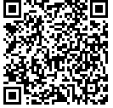
Scan the QR code or visit the website below to register. https://bit.ly/feb2026workshop
or contact us at 859-323-5550
For more information,
contact Sarah Hatch, MSW seha280@uky.edu
Medicaid Waivers
Presented by:
Bluegrass Area Agency on Aging

https://bit.ly/virtualdementiaeducation

